Team 4 – Movie Database

Demonstration Test Plan

Run the program, it will populate the local database from the file MainStorage.txt

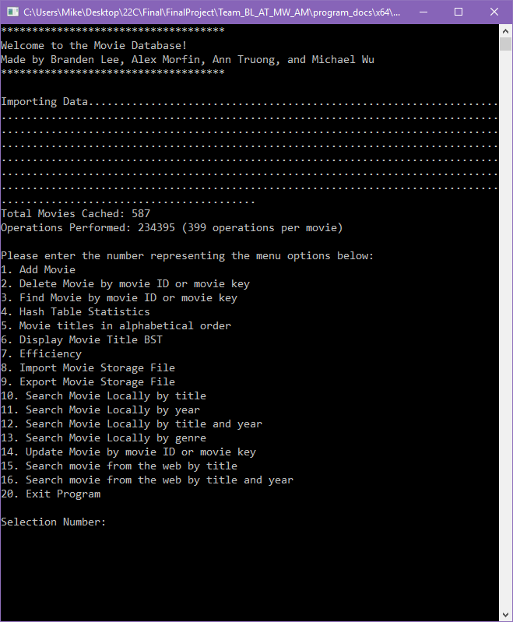

# 

# 

# 

# 

# **Option 1: Add Movie**

Press 1, then follow the prompts in the program to add a custom movie to the database

Enter Integer for Movie ID, Release Year

Double for Rating > 0

Text for Title, Genres, Description

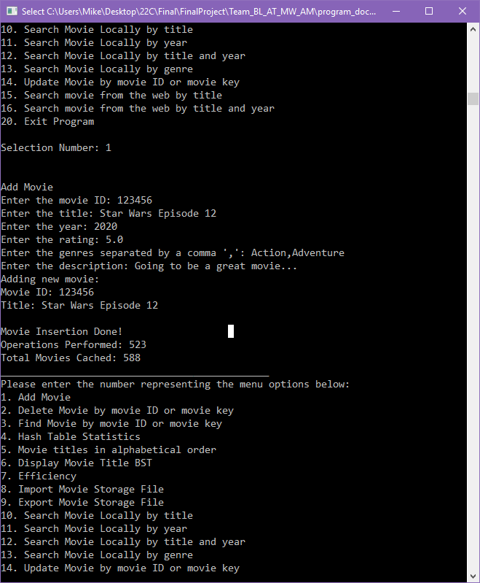

# **Option 2: Delete movie by ID or key**

Select option 2 at the menu, then type the integer value of movie ID or hash table key

Here we delete the movie with an ID of **123456**

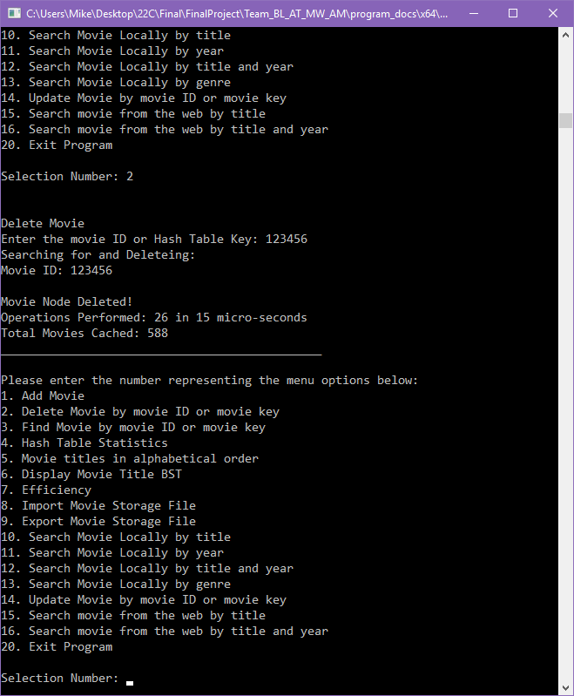

# **Option 3: Find movie by ID or key**

Select option 3 at the menu, then type the integer value of movie ID or hash table key

Here we search for movie by ID **1705**

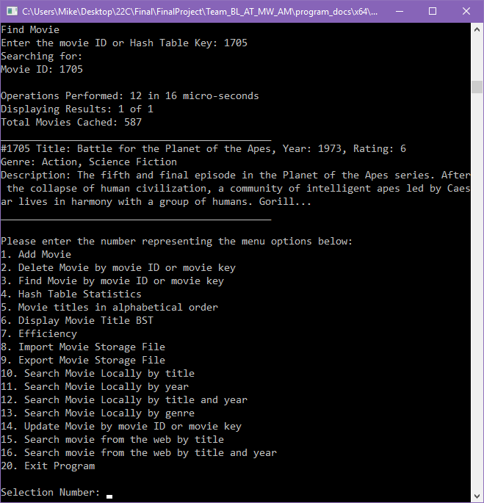

# **Option 4: Hash Table Statistics**

Select option 4 to demonstrate collisions in hashing.

We resolved collisions by use of Linked List

An ‘x’ at the end of the line indicates a collision, with the integer after representing its position in the linked list

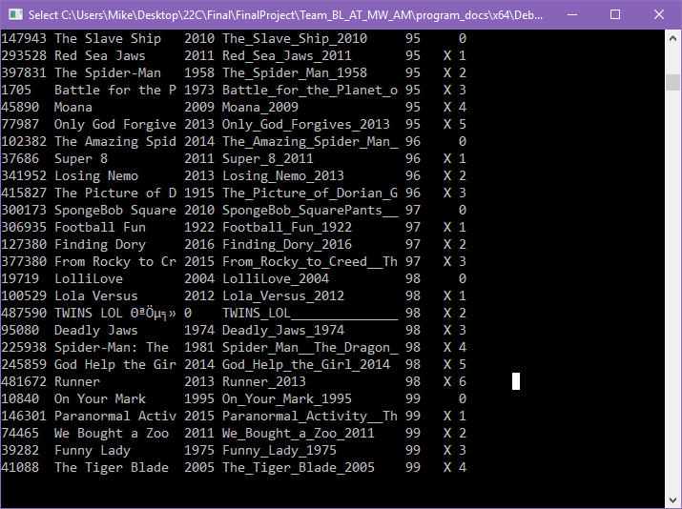

# **Option 5: Movie Titles sorted Alphabetically**

Select Option 5 to see all movies sorted alphabetically by title, with movie ID and year of release

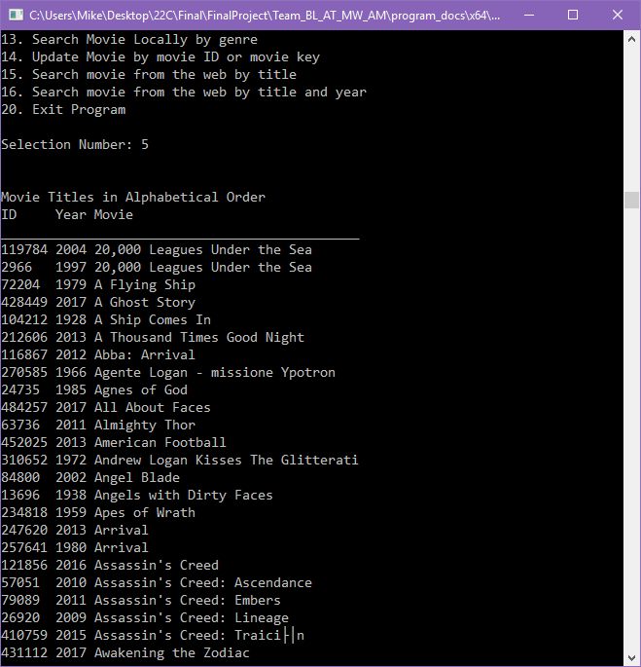

# 

# **Option 6: Display BST of movie titles**

Select Option 6 to see the first 5 levels of the BST of movie titles

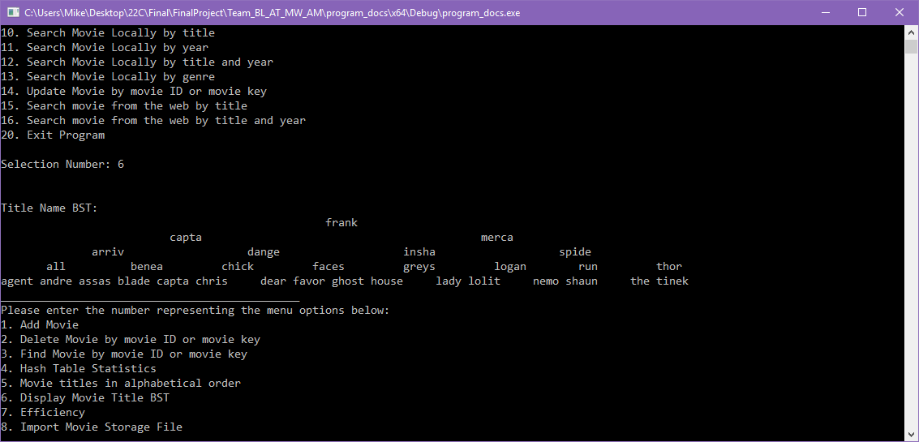

# 

# **Option 7: Display operations that have been done**

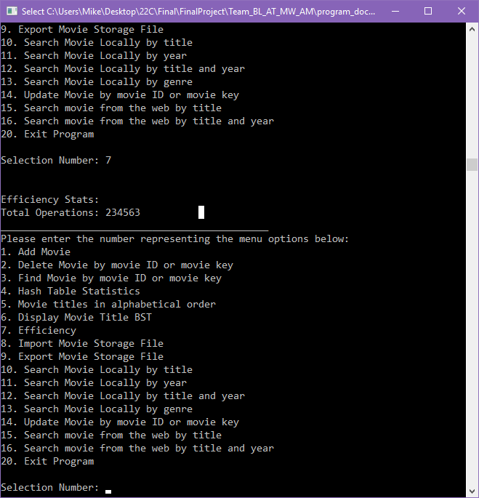

# 

# **Option 8: Import more movies from file**

Enter the filepath to the file with appropriately formatted data.

Here we import “**shrek.txt**” from the same folder we run the program from

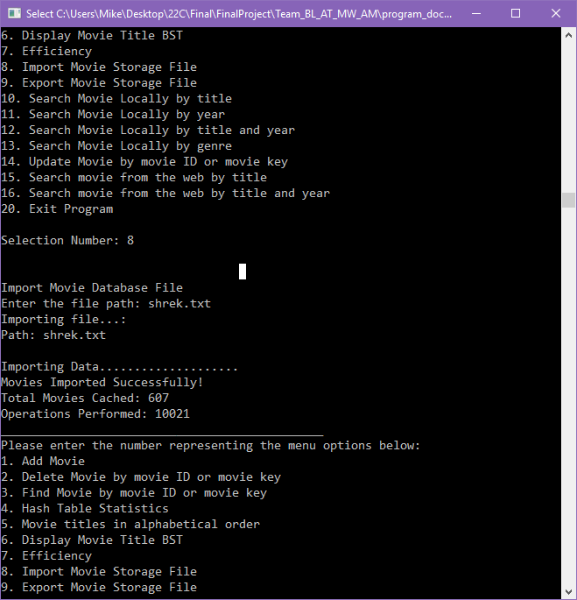

# **Option 9: Export all local data into a file**

Enter the filepath to export all the data into a file, which will be serialized

Here we update to a file called “**updatedmovies.txt**”

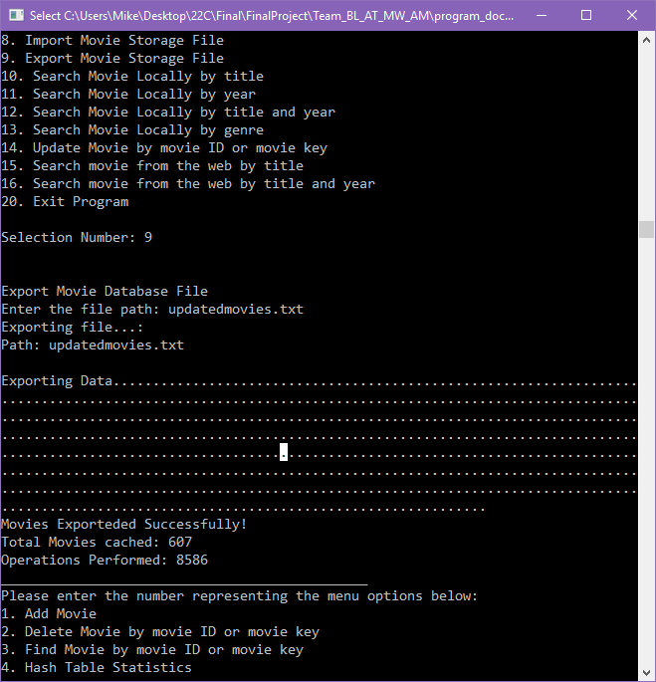

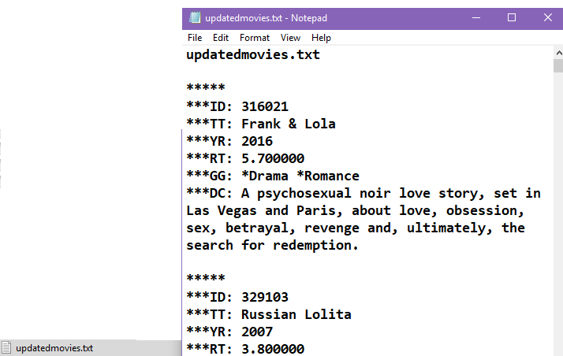

# 

# 

# 

# 

# 

# 

# 

# **Option 10: Search a movie by title**

Enter a keyword to search by

Here we use **‘shrek’**

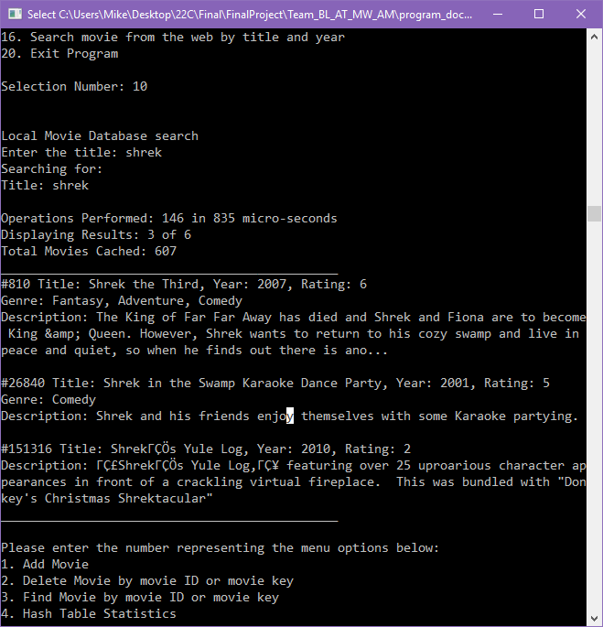

# **Option 13: Search movie by genre**

Type in one genre, such as **‘comedy’**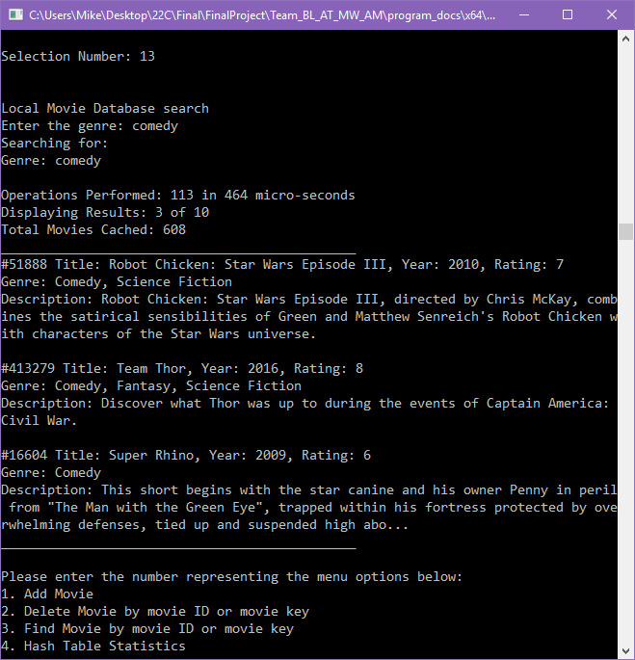

# **Option 14: Update movie by movie ID or key**

Change or edit the data of a movie, select movie using ID or key

Here we use ID **‘10195’**

Hitting ‘Enter’ without any values will preserve the original attribute values in the data

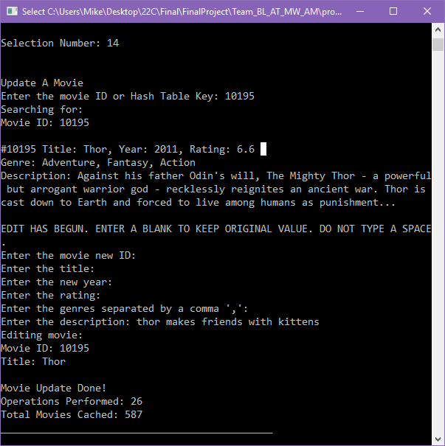

# **Option 20: Quit Program**

